Version 40.7.0

Release April 2015

Contents

Crossover / Turnaround Times 2

9 Hole Bookings 4

Compact View 6

Member Directory 8

New Reports 8

***Crossover / Turnaround Times***

Crossover / Turnaround Times is designed to allow easier timesheet administration for golf clubs by automatically booking the crossover time on the second 9 in which a group will play. This allows clubs to better maximise their tee time capacity on a timesheet. The crossover functionality is primarily designed for 9, 27 or 36 hole facilities although 18 hole venues can also gain benefit from this functionality.

Crossover / Turnaround Times automatically books the crossover time on a predetermined 9 which can be configured in the ‘Manage Groups’ area of the timesheet. Included in this area is an updated interface for the ‘Manage Groups’ (Fig 1.0).

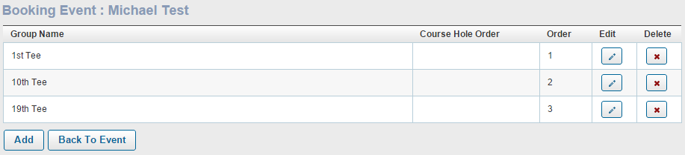

Fig 1.0

The crossover times interface is found at the bottom of the ‘Manage Groups’ screen, a new crossover time can be configured by selecting the ‘Add’ option (Fig 1.1).

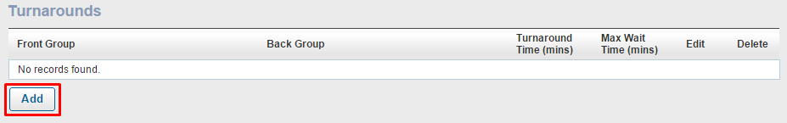

Fig 1.1

A configuration pop up window will appear which will display the required fields to be set for a crossover as per the clubs requirements (Fig 1.2).

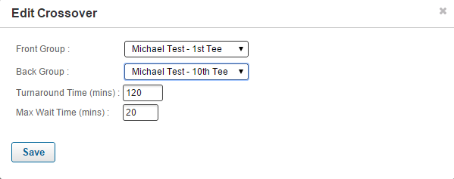

Fig 1.2

Configuration Options Explained

|  |  |
| --- | --- |
| Front Group | The initial tee group for a booking to be made. |
| Back Group | The tee group which takes the crossover booking from the front group. |
| Turnaround Time (mins) | The amount of time between the initial booking on the front group and the crossover booking on the back group. |
| Max Wait Time (mins) | Maximum amount of time a crossover booking can be made after the correct crossover time if that tee time is not available. |

The crossover time will be automatically booked, when configured, if the booking is made by an admin, member or via the kiosk, mobile site or full site.

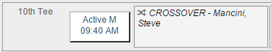

***9 Hole Bookings***

9 Hole Bookings is designed to eliminate the situation where a player wanting to play 18 holes books in with a group of players who are only playing 9 holes thus leaving 18 Hole player with no one to play with for the back 9.

9 Hole Bookings allow members and administrators to signify which bookings are only playing 9 holes or which tee times are available for 9 hole play only.

The configuration for 9 hole bookings can be found in the ‘Edit Rows’ section of the timesheet. To allow 9 hole bookings select the 9 hole option in the ‘Edit Rows’ configuration pop up (Fig 1.3). If the times are for 9 holes only uncheck the ‘Eighteen Hole?’ option.

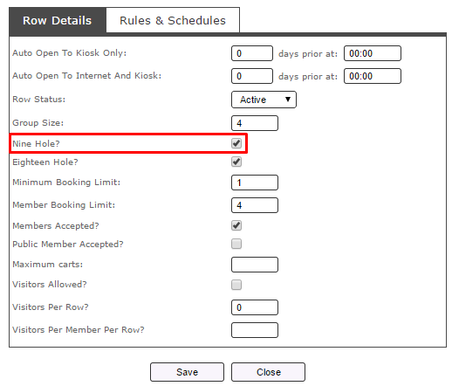

Fig 1.3

Once the 9 hole option is selected each row on the timesheet will show whether it is open for 9 hole play or 9 and 18 hole play (Fig 1.4). If the tee times are for 18 hole play only there will be no label.

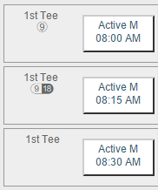

9 Hole Bookings Only

18 Hole Bookings Only

9 and 18 Hole Bookings Available

Fig 1.4

In a row that accepts both 9 and 18 hole bookings there will be an option to notify whether the booking is for 9 holes or 18 holes during the booking process (Fig 1.5) for both administrators and members.

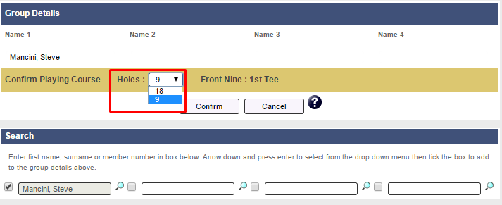

Fig 1.5

If a booking has been made for 9 holes a 9 will appear next to the players name on the timesheet, this is visible for both members and administrators (Fig 1.6).

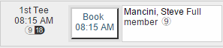

Fig 1.6

***Compact View***

Compact View of the timesheet allows administrators to look at a greater time period of tee times and a greater number of tee groups at any one time. The Compact View is designed to give administrators a much better view of the overall composition of the day’s field.

The compact view can be viewed by selecting the ‘Restore Down’ icon on the timesheet display (Fig 1.7).



Fig 1.7

The initial compact view will highlight those times which have already been booked. To view the player names in compact view select the T+ icon (Fig 1.8). To toggle back to the full screen display select the ‘Restore’ icon once again.

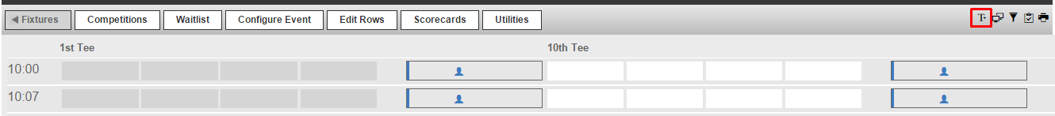

Fig 1.8

*Moving Players in Compact View*

Moving players in compact view is the same as in the normal full view of the timesheet. Select the booking you wish to move and then the cell which you want to move the booking, once selected choose the ‘swap cells’ option.

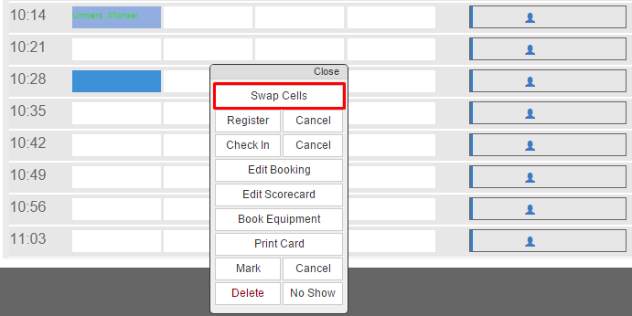

Fig 1.9

Fig 2.0

*Filter Groups*

The compact view development also includes the ability to filter the display by groups. This can be done by selecting the filter icon (Fig 2.1), from the configuration pop up that appears select the groups you wish to view on the timesheet (Fig 2.2).

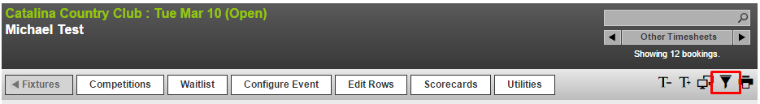

Fig 2.1

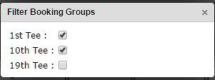

Fig 2.2

***Members Directory***

The first stage of Pay 4 Play will also include an updated interface for the member’s directory. After searching for a player the new member’s directory will have an arrow at the end of each search result.



Selecting this arrow will provide further detail about this member such as email address and will also include the ability to ‘Send SMS’ if the SMS functionality is configured for the site.

***New Reports***

The new release of the MiClub software will include 2 new reports: No Show Report and Cancellation Report.

*No Show Report*

The ‘No Show’ feature allows administrators to mark bookings as ‘No Show’ as well as produce a report on this data.

**Marking a Booking as ‘No Show’**

To mark a booking as ‘No Show’ select the players name on the timesheet.

Once the players name is highlighted select the ‘No Show’ option.

[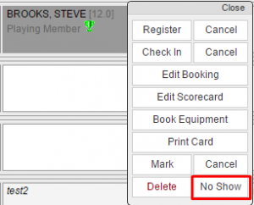](http://support.miclub.com.au/cms/wp-content/uploads/2015/03/NoShow.png)

When a player has been marked as a ‘No Show’ the text (No Show) will be added next to their booking.

[NoShow2](http://support.miclub.com.au/cms/wp-content/uploads/2015/03/NoShow2.png)

*No Show Report*

The ‘No Show Report’ can be found in the Reports section (Fixtures -> Reports)

Select the date range required for the report and select ‘Generate Report’.

[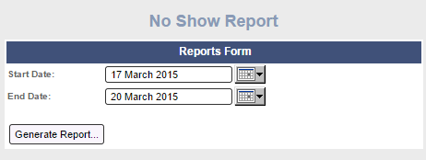](http://support.miclub.com.au/cms/wp-content/uploads/2015/03/NoShowReport.png)

The report produced will show all the bookings which have been marked as ‘No Shows’ across the date range selected.

*Cancellation Report*

The Cancellation Report for public bookings allows administrators to add a ‘Cancellation Reason’ and ‘Comments’ as to why a public booking was removed from the timesheet.

When deleting a public booking a pop up window will appear asking for a ‘Cancellation Reason’ and an optional area for ‘Comments’.

[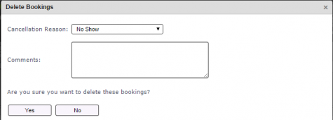](http://support.miclub.com.au/cms/wp-content/uploads/2015/03/DeleteBooking.png)

* The following are the options for ‘Cancellation Reason':

– Cancelled (Refund Required)

– Cancelled (Tentative Booking)

– Cancelled (Witheld Payment)

– Late Arrival

– No Payment

– No Show

– Other

– Weather

 The Cancellation Report can be found in the ‘Reports’ section (Fixtures -> Reports). To produce the report elect a date range and whether you want the report on Booking Date or Cancellation Date and select ‘Generate Report’.

[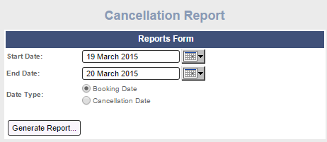](http://support.miclub.com.au/cms/wp-content/uploads/2015/03/Cancellation-Report.png)

The Cancellation Report includes fields for Cancelled By, Booking Name, Tee Time, Group, Green Fee, Equipment, Dollars Cancelled, Reason, Comments, Cancel Date.

[Cancellation](http://support.miclub.com.au/cms/wp-content/uploads/2015/03/Cancellation.png)