Qantas Golf Club
Training Procedure
Course Management of Inventory Times
Version | 0.2
Date | 2 October 2014

Table of Contents
1. Overview 3
1.1. Log In to QGI 3
1.1. Fixtures List: Booking Sheets 4
1.2. Bookings 4
1.3. Managing Master Teesheet and QGC Teesheet Bookings 6
2. Tee Time Inventory Management 7
2.1. Initial Setup 7
2.1.1. Remove a Tee Time 7
2.1.2. Adding Tee Times to Sell 7
2.1.3. Course Maintenance or Competition details Notification 9
2.1.4. Setting Special Prices/Changing Fees 11
2.1.5. Email Reminder or Course Cancellation Notice 11
2.2. Advanced Features 13
2.2.1. Green Fee Categories 13
2.2.2. Booking Rules 15
2.2.3. Create Tee Sheet Templates 17
2.2.4. Create Events and applying booking templates 21
2.2.5. Booking Reports 22
3. MiClub Support 24

- Overview
A MiClub product site http://qgi.miclub.com.au has been created for the purpose of providing courses which do not use MiClub booking system to use online tee sheets to manage list/sell inventory times to QGC. A user account will be assigned to your course on this site which will restrict you to only access your clubs tee times.
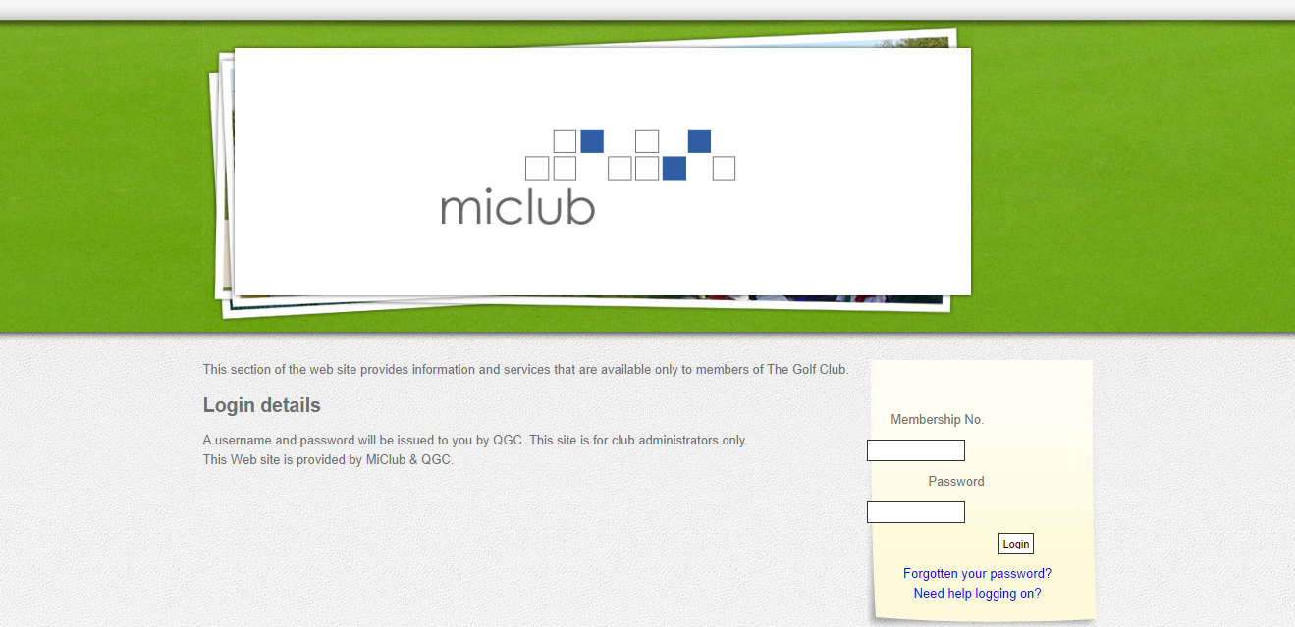
  - Log In to QGI
Log into the site http://qgi.miclub.com.au with the assigned Club’s user account.

This will direct you directly to Admin Portal Home page.
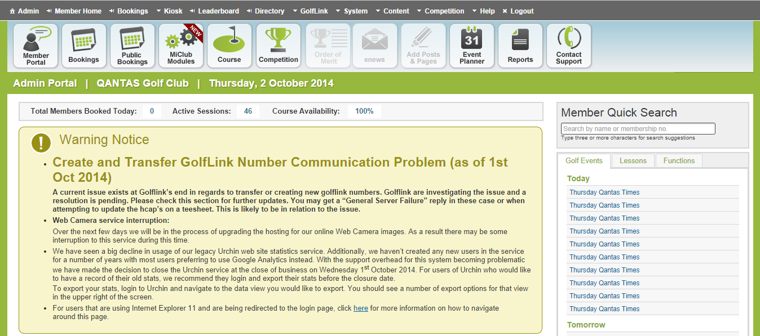
This user account gives you access to view bookings made, make modifications to green fees, add and remove times, reports and send email notifications to QGC members who have made a booking.
  - Fixtures List: Booking Sheets
To enter a teesheet simply click Bookings in the top banner (box highlighted in green) or access the designated tee sheet from the Quick Access links on the right side of the screen under the Golf Events tab as highlighted in the red box on the image below.
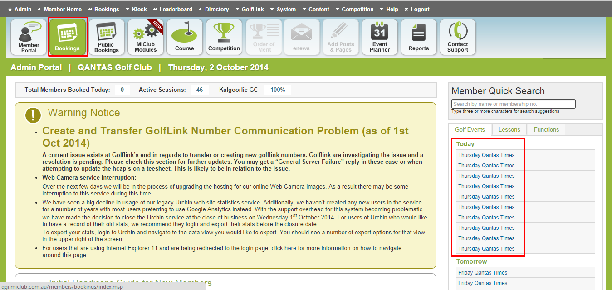
Click on the title of the event i.e. Thursday Qantas Times. You can access future teesheets by clicking on the calendar month on the left. By default the next 28 days of teesheets will be listed.
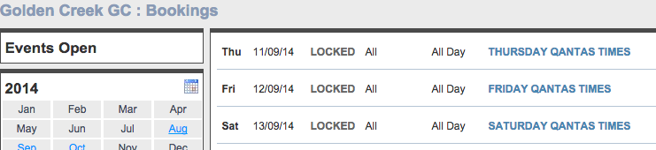
  - Bookings
Bookings made via QGC will appear in the tee sheet with the name of the booker as per the screen shot below. A QGC member can make a booking for up to 4 people. If a booking is made for multiple players, the booking will appear on the tee sheet under the same name and contact details in each cell corresponding to the number of players as shown in the screenshot below.
The colour around the tee time indicates the booking rule applied to that particular tee time (refer to section 2.2.2. Booking Rules for more information on booking rules).
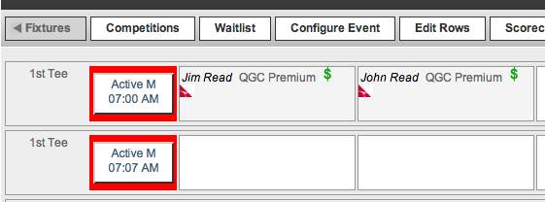
Clicking on the booking cell and selecting the edit booking option, one can find QGC member contact details.
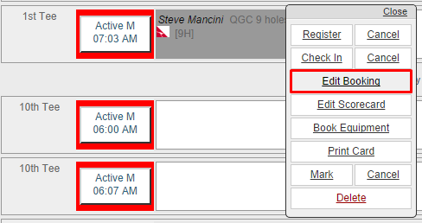
In the popup window, the members details such as phone and email contact details will be displayed.
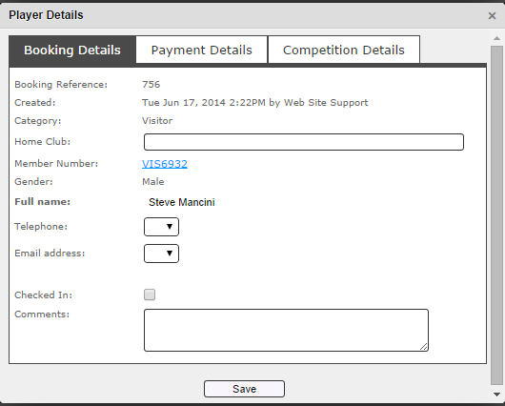

Note: Any changes made to these bookings on QGI will not flow back to QGC, and the player will not be informed of these changes unless the golf club representative contacts the customer using the member’s details mentioned above to inform them of any changes done to their bookings.
  - Managing Master Teesheet and QGC Teesheet Bookings
If a master club teesheet is in use at the club for bookings other than QGC, it is the club’s responsibility to manage both teesheets to ensure duplicate bookings do not occur. There are a few ways to keep the master teesheet updated with bookings made from QGC:
- Block out times dedicated to QGC on the master teesheet
- When a booking is made from QGC you will receive an email to indicate the number of players and time selected. You can update these details on the master or you can refer to the QGC site if you wish to instead.

Note: A QGC booking can be made up to 28 days in advance.

- Tee Time Inventory Management
  - Initial Setup
MiClub will initially assist you in setting up teesheet templates which will have set times to sell to QGC. These templates will be applied to teesheets well into the future. In case, you may want to create new timesheet templates, new green fee categories, new booking rules and more events which is typical of initial setup process completed by MiClub staff, refer to section 2.2. Advanced Features.
If modification to the tee times on a particular day is required, then you have multiple options, such as to:
- Remove a tee time(s) to sell
- Add tee time(s) to sell
- Modify a green fee amount or add a special rate
- Modify restriction on times i.e. comp/gender etc…
    - Remove a Tee Time
If tee times listed need to be removed from QGC you simply select the row (press on the first column area right under the fixtures tab to highlight) then select the Reserve All option then press apply. The row will be reserved out now and be unavailable on QGC to be booked.
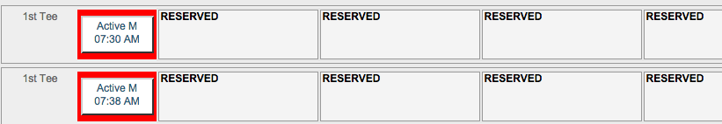
    - Adding Tee Times to Sell
Enter the teesheet for the day in question and select the Edit Rows menu and select the Add Rows button as shown below.
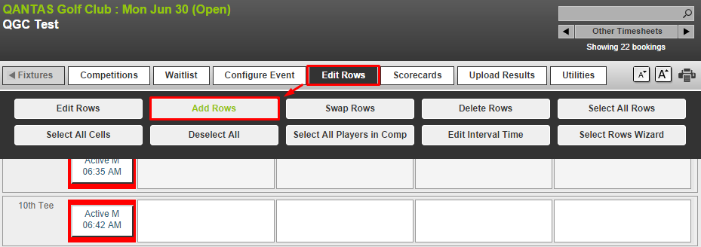
Enter the start time of the additional row, select the intervals, interval duration, row status, and group and click on save. The new row(s) is created in the timesheet.
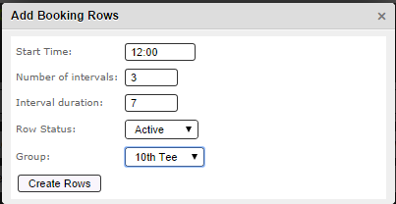
Return back to the teesheet and select the new row added (click in the first column). A popup will appear on the last row selected with an option to “List on QANTAS”. Select this and the list of Booking Rules will appear as per the screen shot (for more details on Booking Rules, refer to section 2.2.2. Booking Rules)
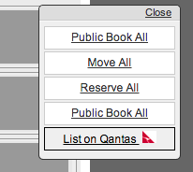

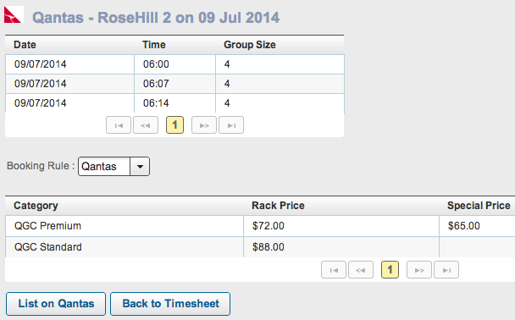
Select the appropriate Booking rule and press the List on Qantas button then close. The rows in the teesheet should now have a colour applied to the group column to indicate that the rules has been applied successfully (different booking rules have different color codes, for more information on how to create new booking rules or edit existing ones, refer to section 2.2.2. Booking Rules).
    - Course Maintenance or Competition details Notification
During periods of course maintenance, it is required to add a notice regarding the details that may affect the playability of the course so that this is shown to the members of QGC.
To apply a message, access the Configure Event – Details and Opening and select the Public Configuration tab from within the teesheet as shown below.
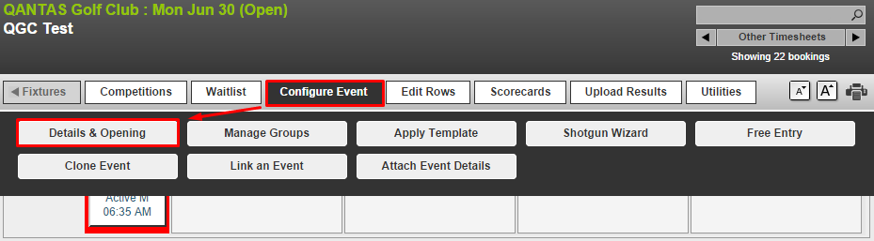

Enter comments in the Public Event Title for notification regarding the course or competition information and save the changes. These comments will appear on the QGC website so that they are made visible to the member while searching for tee times.
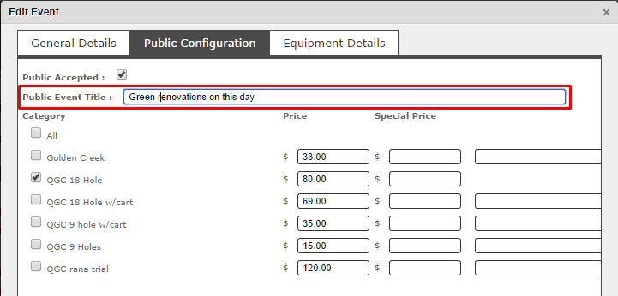

    - Setting Special Prices/Changing Fees
You can apply a special price on certain days or simply change the default green fee on a teesheet.
Select the teesheet in question and press the Configure Event and then the Details and Opening button. Press the Public Configuration tab to display the green fee types as shown in the screenshot below.
Here you can add a special price or change the default price for that day. These special prices will be displayed on the QGC website so that they are visible to the member when booking tee times.
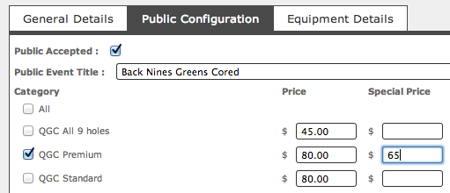
    - Email Reminder or Course Cancellation Notice
If a course is to be closed due to weather and there are QGC bookings made for the day, the club is responsible to contact the QGC member directly. The contact details of the member can be accessed by clicking on the booking on the teesheet, the clicking of edit booking. The contact details will be displayed in the popup window.
It is also the club’s responsibility to contact QGC to inform them of any club-initiated cancelations.
If directly contacting (i.e. phoning the member) is not possible then there is a message service from the teesheet that can be used to inform the players of the cancelation. This function is under the teesheet utilities menu – manage messages, as shown below.

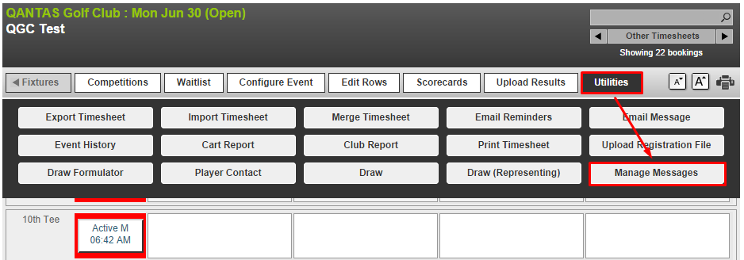
Modify the message in the email reminder section then save the template.
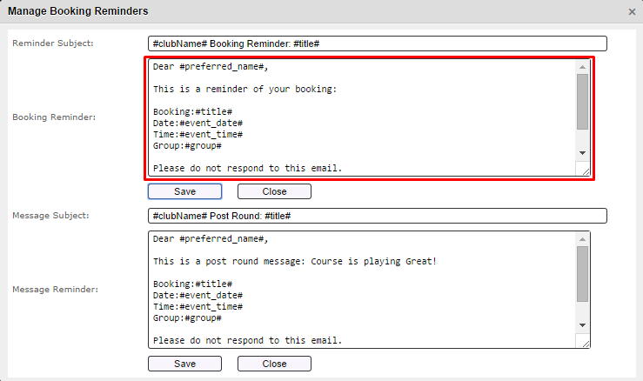
Now press on Email Reminders button in the utilities menu and press the Email Booking Reminders button to send.
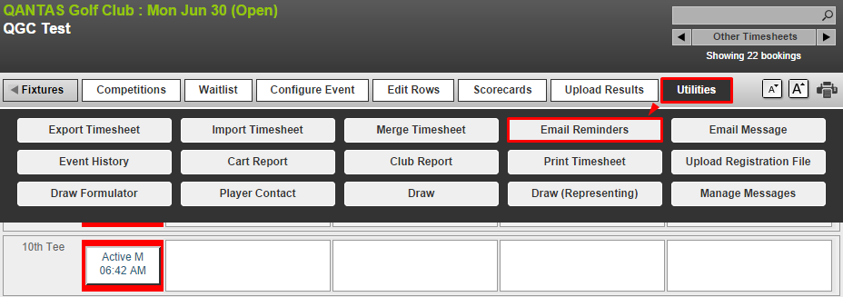
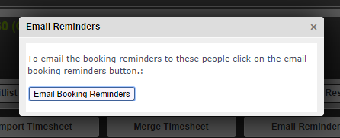
  - Advanced Features
The following sections are related to creating new green fee categories, booking rules, timesheet templates and creating more events which is typical of the process initially completed by MiClub staff. These steps would need to be followed if you require to update templates and apply them to future dates.
    - Green Fee Categories
Click on the “Public Fees” tab from the bookings menu bar and then click on the Add Fee Category button at the bottom of the screen.
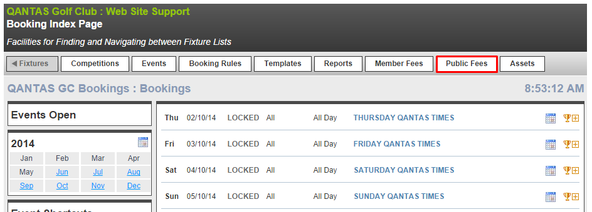
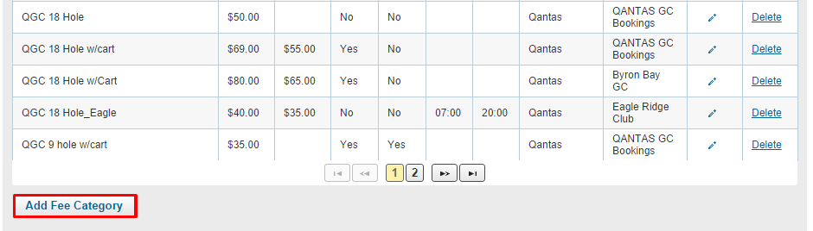
Fill in the relevant fields in the box that opens:

Category Name: The name of the category which will appear on the QGI site. (Required)
Price ($): The standard price of the category. (Required)
Special Price ($): The special price for this category. (Optional) PLEASE NOTE: If the special price field has a value inputted this is the price which will show on the QGI site.
Includes Cart: If the green fee includes a cart check this option. (Optional)
9 Hole: If the fee is a 9 hole category check this option. (Optional)
Start Time: Earliest time this category can be booked (Optional). Eg. Afternoon rate may have a start time of 12:00.
End Time: Latest time this category can be booked (Optional). Eg. Morning rate may have an end time of 11:59
Booking Resource: The booking resource will always be the name of the club. (Required)
Booking Client: The booking client will always be Qantas. (Required)

Press the Proceed button.
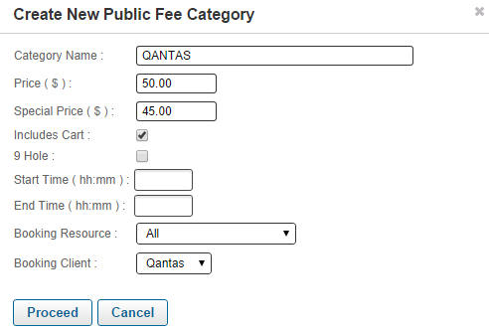
    - Booking Rules
Booking Rules are used to apply restrictions based on gender, Golflink Number (union), default prices and to flag rows as competition times.
To create or modify booking rules Click on the Booking Rules in the Bookings menu bar at the top as shown in the screenshot below. A list of exiting booking rules is listed.

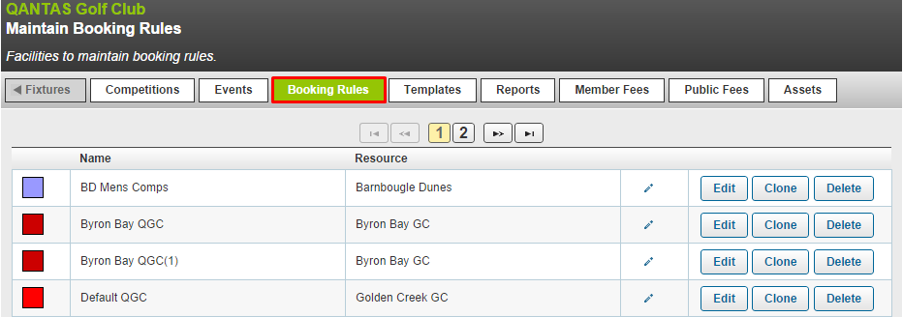

Create a New Booking Rule
To create a new booking rule, scroll to the bottom of the page and click on Add Rule.
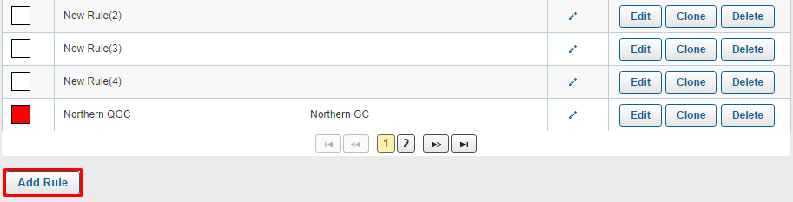
Fill in the details of the booking rules:
Booking Rule: Title and colour. (Required)
Category Restrictions: Select the ‘All’ option. (Required)
Member Handicap Restrictions (Ignore)
Visitor Handicap Restrictions (Ignore)
Age Restrictions (Ignore)
Competition Restrictions: (Optional) If the rule is going to be used in competition play select ‘Competition’. If the club requires players to have a Golflink number select ‘Union Number Required’.
Booking Client Restrictions: Select Qantas. (Required)
Public Category Restrictions: Select the fee categories which apply to the booking rule. (Required)
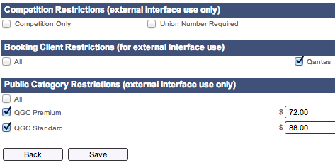
Press Save when finished. The new rule will appear in the list of booking rules.

Edit an Existing Booking Rule
To edit an existing booking rule, click on edit to right of the designated booking rule. The booking rule details will open. Make the changes, then click on save.

    - Create Tee Sheet Templates
Detailed instructions on how to create teesheets and templates can be found here: http://support.miclub.com.au/cms/category/bookings-club-admin/
Click on Fixtures then select Templates.
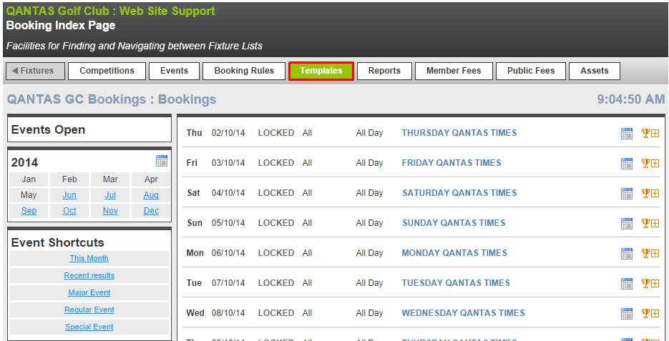
A list of existing templates appears.
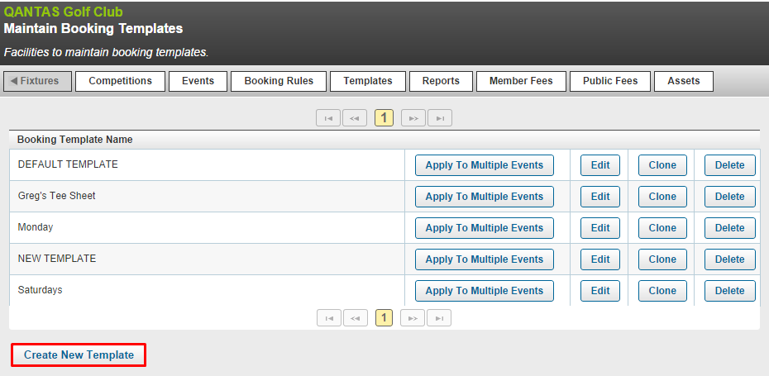
Click on Create New Template at the bottom of the page as highlighted in the red box above.
Click on Configure Event in the top menu bar, then click on Details and Opening and enter a suitable Title for the Template i.e. Monday to Friday and press save.
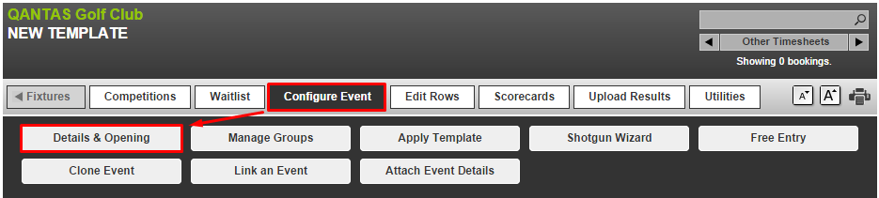
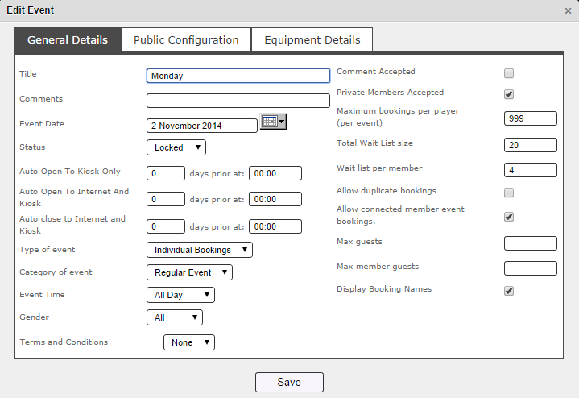
Click on Manage groups under Configure Event.
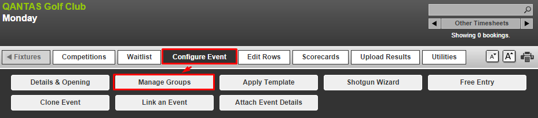
Add Group, entering the name of the Tee i.e. 1st Tee, you can add additional Tees as well i.e. 10th Tee. Click on Save. The system will save the added groups but will keep the window open in case you want to add additional groups. If not, the click on close.
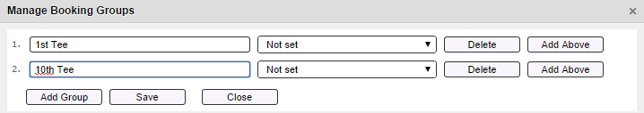
Press the Edit Rows menu and select the Add rows.
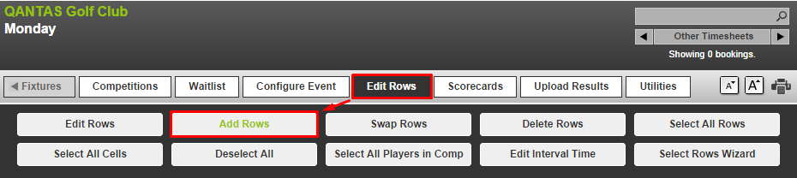
Enter the start time, number of internals, interval duration and which tee, then press create. Repeat for each group/tee block.
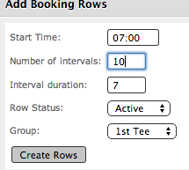

    - Create Events and applying booking templates
From the Fixtures page select Templates.
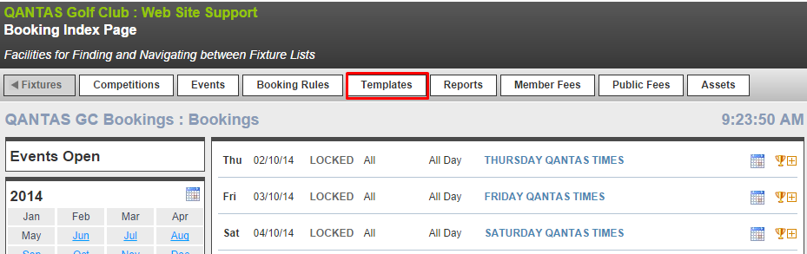
Press the Apply to Multiple Events for the selected Booking Template as shown below.
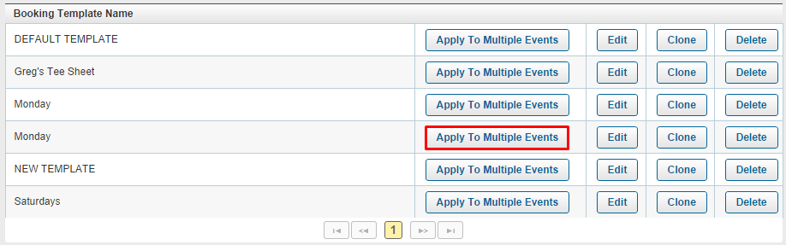
Select the days of the week that the template should apply to. Select the date range to apply the template.Select the “Create New Events” option. Click on Apply Template.
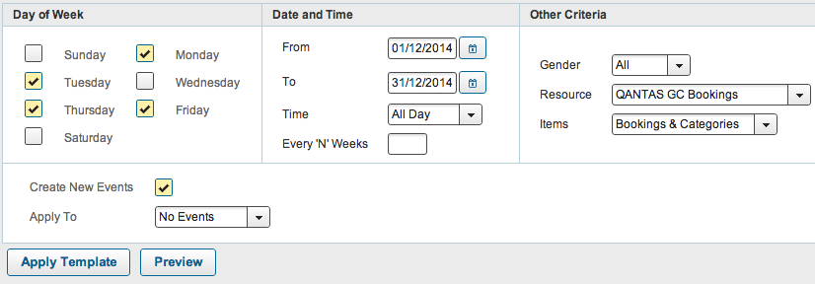
The template will then be applied to the teesheets of the days selected within the time range indicated above. You can check that the template has been applied by clicking on one of the teesheets that fulfills the day and date criteria selected above.
    - Booking Reports
Access the Reports menu as shown in the image below.
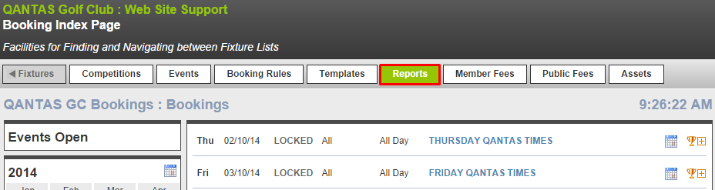
Scroll down and locate the Public Booking Reports by Interface report. Select the date range and then Generate button.
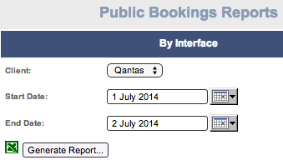
The information retrieved will include details of the booking names, date and time
- MiClub Support
Email : support@miclub.com.au
Phone: 08 9444 5300
Web:
http://support.miclub.com.au

